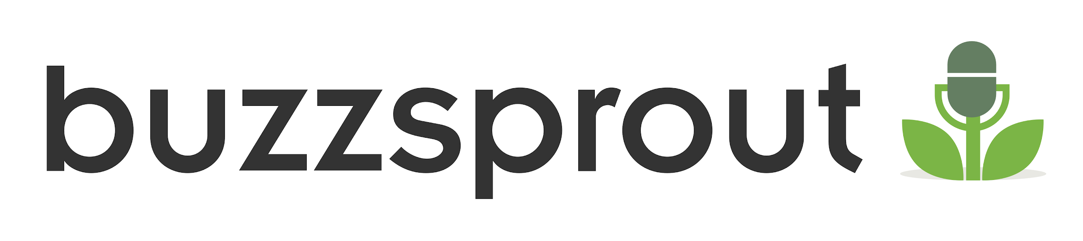
Podcast Script Template

Sponsor message
Intro: Duration: ( ___)
- Set the stage for your episode. Include details that set up your episode’s theme. State podcast name, why your show exists, who you are, etc.
Opening music jingle & sound effects
[Lead into episode’s content]
Topic 1: Duration:( ___ )
- Main point
- Supporting point
- Supporting data
- Supporting quote
Segue (can be a sound effect, short musical clip, or a phrase)
Topic 2: Duration:( ___ )
- Main point
- Supporting point
- Supporting data
- Supporting quote
Sponsor message
Topic 3: Duration:( ___ )
- Main point
- Supporting point
- Supporting data
- Supporting quote
Segue (can be a sound effect, short musical clip, or a phrase)
Outro: Duration:( ___ )
- Closing remarks (summarize episode themes)
- Call to actions
Sponsor message
Closing music jingle/sound effects

